Project: Moffat Bay Marina Website | Blue Team Moffat Bay Marina Website Test Cases
Course: CSD460 – Capstone in Software Development | Jonah Aney, Justin Marucci, Nardos Gabremedhin, Amanda Wedergren
Description: Website for Moffat Bay Marina to accept reservations for slips
Date: February 15, 2026
To complete the test case plan, fill out the information for Project, Course, Description and Date in the header below.
.

For each test, the developer should: provide a test description, a test objective, the developer name and date tested. For each step, fill out the actions to be taken and describe the expected results, and indicate yes or no for each step depending upon the result. The peer tester should provide their name, date tested, indicate yes or no for each step depending upon the result, and a screenshot (thumbnail) of the result.

Test 1 | User has reservations
 | Test Objective: Verifies that reservations display when the user is logged in and has a past or present/future reservation | Developer: Amanda Wedergren  Date tested: 2026/02/15 | Peer tester: Jonah Aney  Date tested: 2026/02/15
Step | Action | Expected results: | Developer pass/fail | Tester pass/fail  + Screenshot
1 | Log in to a user account (roger@example.com, Password1) | Successfully log the user in | pass | Yes  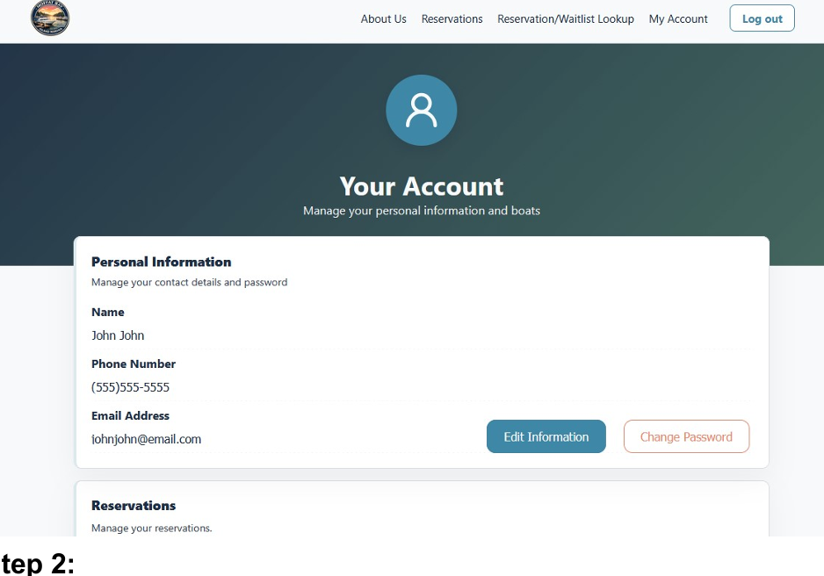
2 | Click on the “Reservation/Waitlist Lookup” link in the menu | Directs the user to the Reservation Summary page | pass | Yes  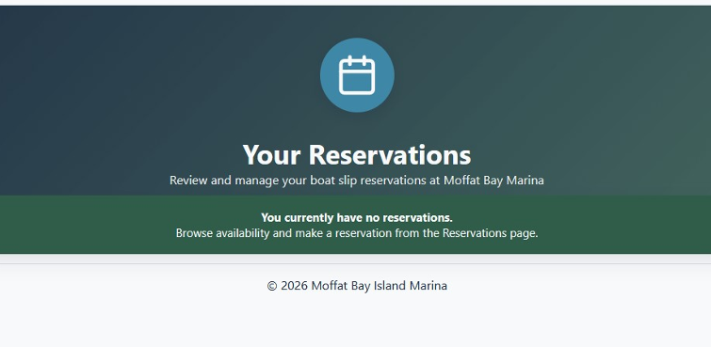
3 | Check details of reservations for user | Reservation details will display | pass | No  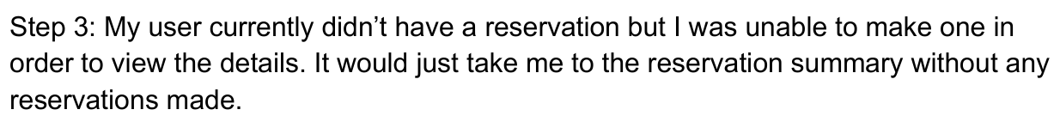
4 | “Edit” and “Cancel” buttons | Confirm the buttons allow the user to edit or cancel a reservation | pass | No  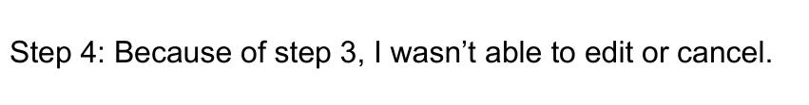
Comments | The reservation summary page did not successfully show any reservations tied to the login in user. While this happens on the first visit to the page, subsequent visits show the data as required.

Test 2 | Links work as expected
 | Test Objective: Confirm the menu links go to the correct pages | Developer: Amanda Wedergren  Date tested: 2026/02/15 | Peer tester: Jonah Aney  Date tested: 2026/02/15
Step | Action | Expected results: | Developer pass/fail | Tester pass/fail
1 | On the Reservation Summary page, click on the logo in the menu | Takes user to home (index) page | pass | Yes  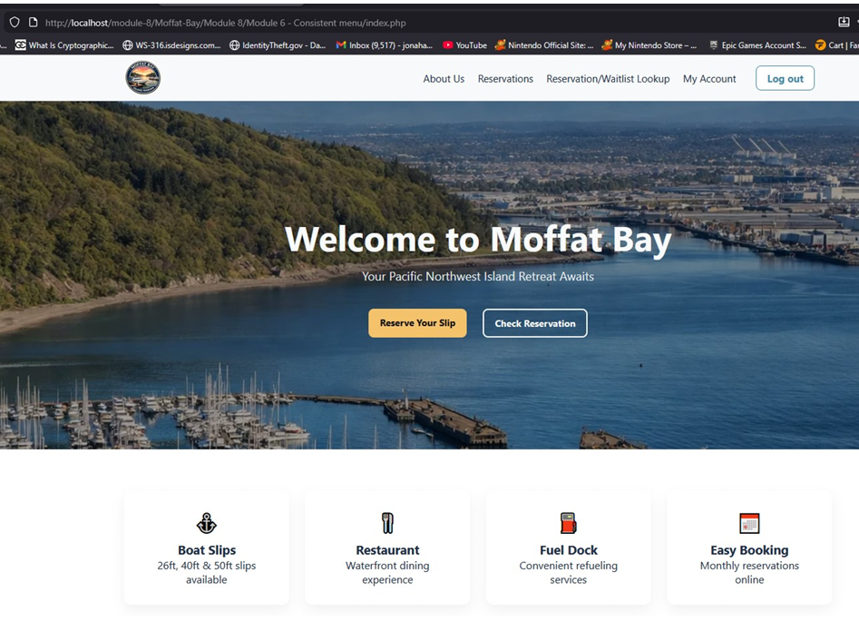
2 | Click the back button. Choose another menu link (about, your account, etc) | Confirm the link chosen directs to the correct page | pass | Yes  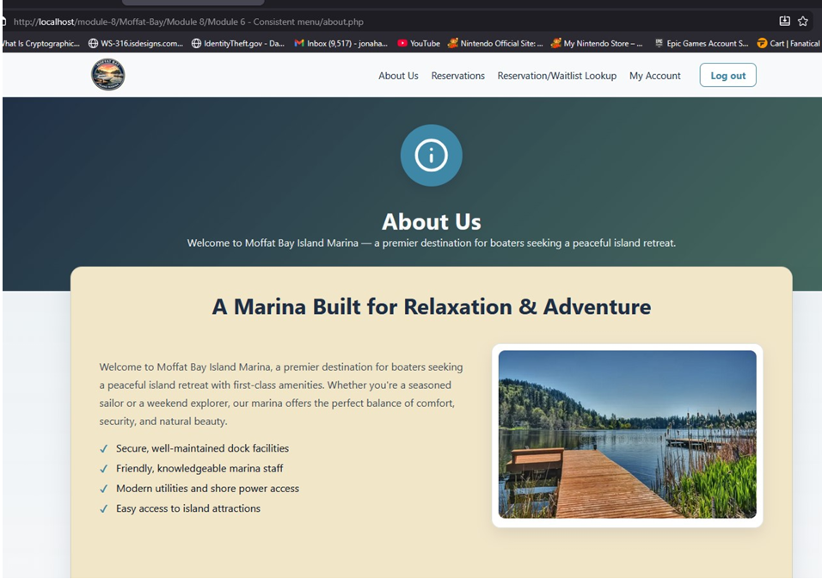
3 | Click the back button again, choose another link in the menu to test | Confirm the link chosen directs to the correct page | pass | Yes  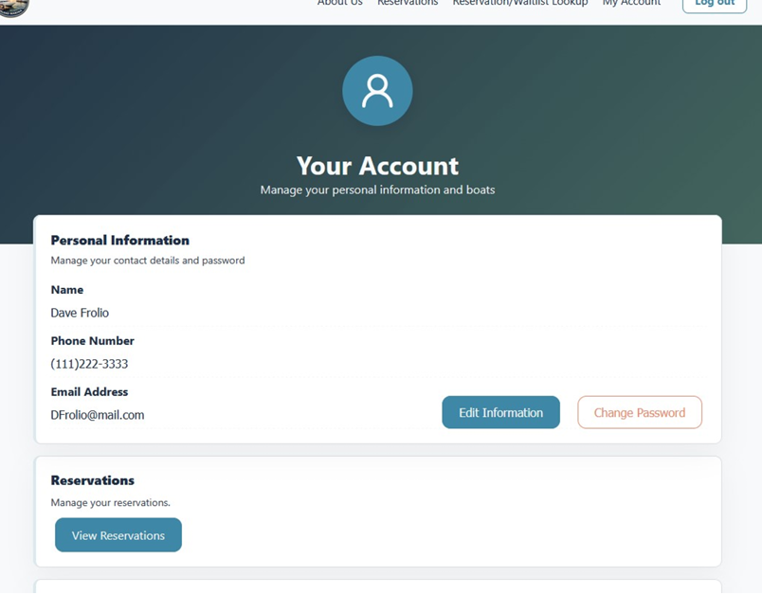
Comments | All navigation works as expected between pages. Since the Contact Us page was removed, we needed to make sure that the Contact information was still accessible to customers. A link still directs specifically to the Contact Information for ease for our customers.

Test 3 | Information and images display correctly
 | Test Objective: Ensure that data and images display | Developer: Amanda Wedergren  Date tested: 2026/02/15 | Peer tester: Jonah Aney  Date tested: 2026/02/15
Step | Action | Expected results: | Developer pass/fail | Tester pass/fail
1 | Click on the About Us link on any page on the website | Should direct the user to the About Us page | pass | Yes  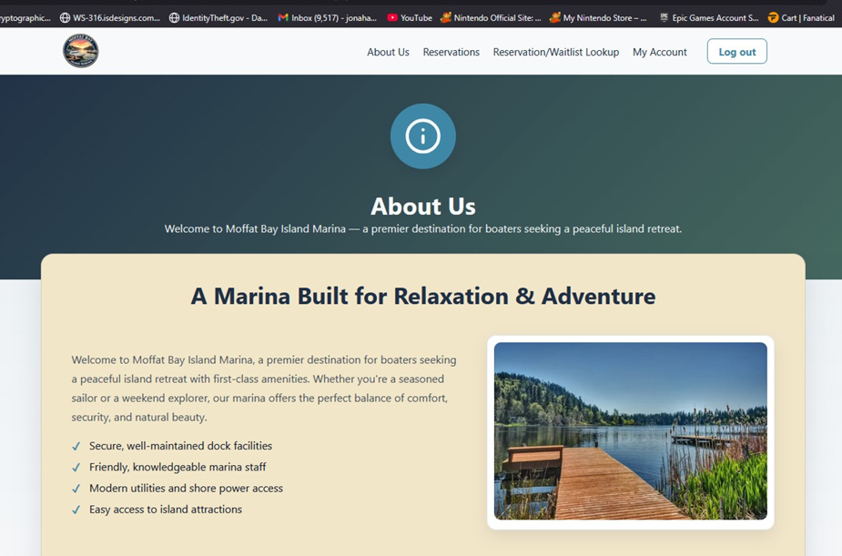
2 | Scroll to confirm all images load | Images load and display correctly | pass | Yes  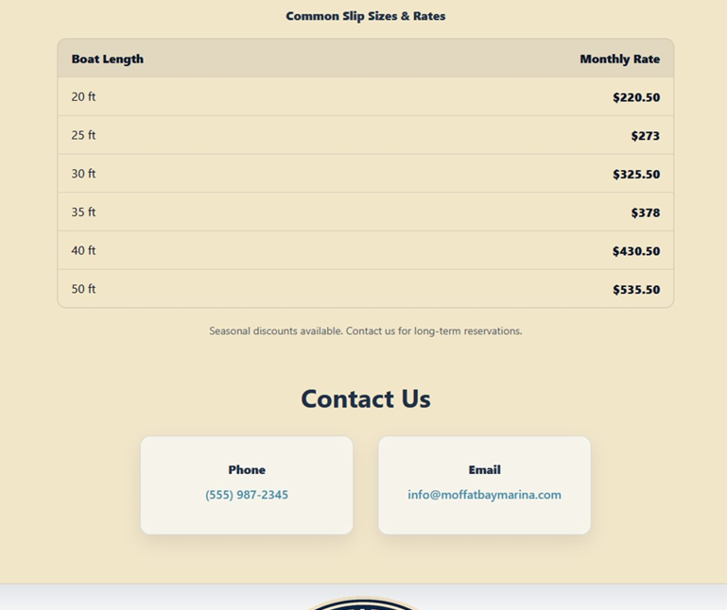
3 | Check contact information displays | Contact information should display at the bottom of the About Us page in two cards | pass | Yes  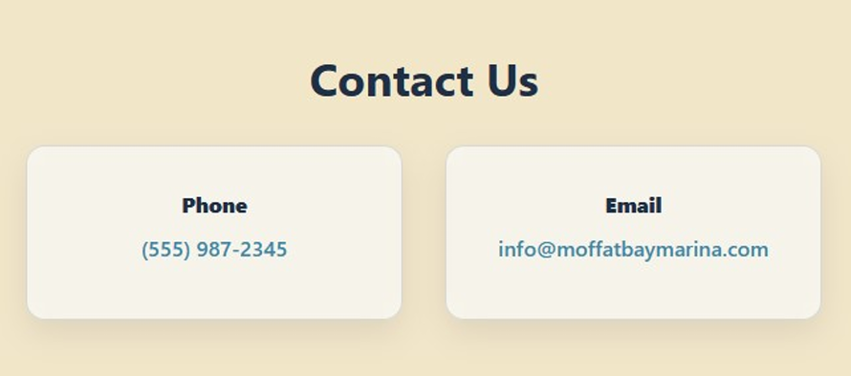
Comments | All data and images are displaying as expected. Sometimes including images can make the page broken or not show up correctly.

Test 4 | Links direct to the right location on the About Us page
 | Test Objective: Ensure that all links work as expected | Developer: Amanda Wedergren  Date tested: 2026/02/15 | Peer tester: Jonah Aney  Date tested: 2026/02/15
Step | Action | Expected results: | Developer pass/fail | Tester pass/fail
1 | Go to the home/index page by clicking on the logo from any page | Direct to the Home page | pass | Yes  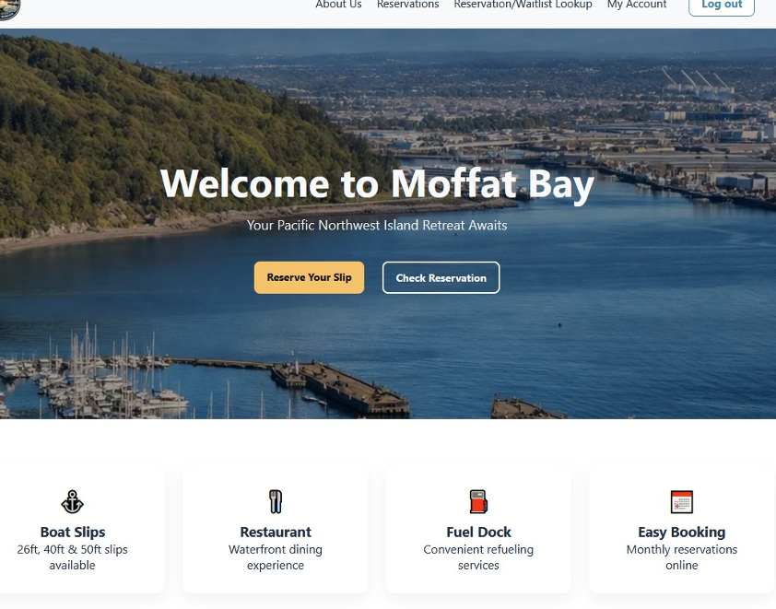
2 | Click the “Learn more about us” link (near bottom of page) | Button should direct user to the top of the About Us page | pass | Yes  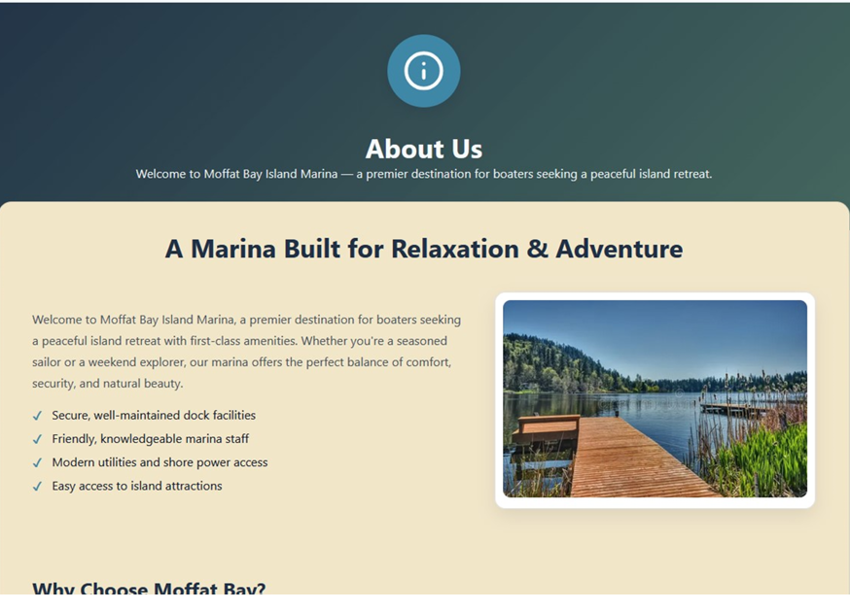
3 | Return to the Home page and click on the “Contact Us” button (bottom of the page) | Button should direct the user to the bottom of the “About Us” page, which shows the Contact information | pass | Yes  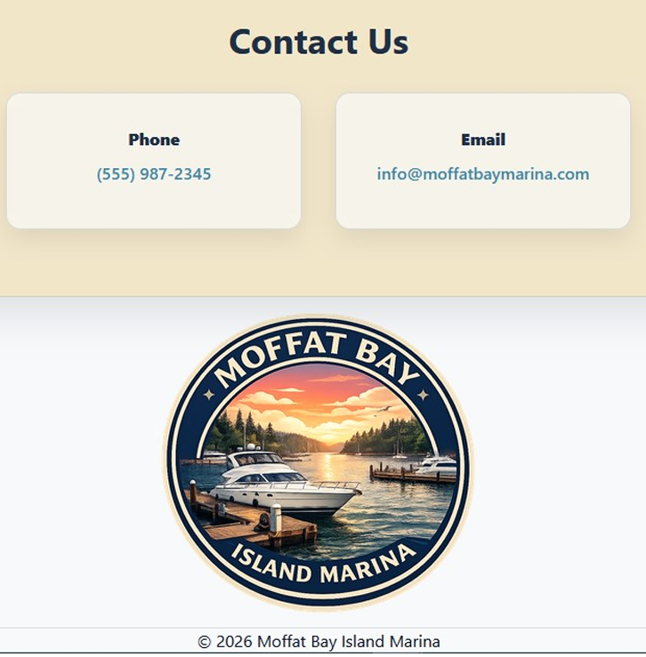
Comments | Since the Contact Us page was removed, we made sure that our original links to the “Contact Us” page still go directly to the Contact Us information, even though there is not a direct page for that information

